**PERIPHERAL NERVE BLOCK (PNB) TECHNIQUES**

**(LANDMARK-GUIDED)**

**PENILE NERVE BLOCK**

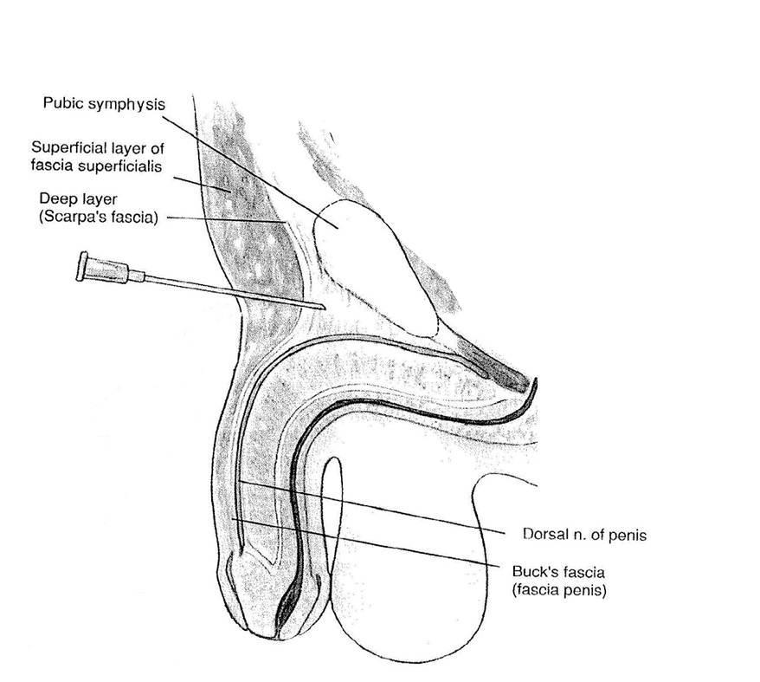

The dorsal nerves of the penis are mainly responsible for the sensory innervation of the skin of the penis, with terminal branches to both dorsal and ventral aspects. The dorsal nerves are terminal branches of the pudendal nerves which arise from the sacral plexus (S2, S3, S4). Additional sensory innervation is from the genitofemoral and ilioinguinal nerves and posterior scrotal branches of the perineal nerves that run paraurethral to the ventral surface of the frenulum.

After emergence from the parent nerve trunk, the dorsal nerves pass under the pubic bone and run within the subpubic space. They then enter the substance of the suspensory ligament where they are accompanied by two dorsal arteries and the dorsal vein of the penis. The suspensory ligament divides the subpubic space into two compartments that may be noncommunicating.

**Subpubic approach to dorsal nerves of the penis**

* Safe and reliable technique
* Using a 23 G needle, puncture point approximately slightly lateral to the midline, avoiding the dorsal penile vessels. Place the needle almost perpendicular to skin with a slight caudal and medial slope
* Enter the subpubic space by piercing Scarpa’s fascia
* Place LA (plain bupivacaine or levobupivacaine 0.25%) 0.2ml/kg up to a maximum of 10 mls within space.
* The use of adrenaline in the LA solution is contraindicated as it can result in spasm of the dorsal arteries and glan necrosis.

Nerve supply to the ventral surface of the penis may also be supplied by the genitofemoral and ilioinguinal nerves. Local infiltration of the frenulum is useful to block sensory fibers from these nerves.

**Subcutaneous ring block**

Local anesthetic given as a circumferential subcutaneous ring at the base of the penis - avoid use of adrenaline. This is often used as a rescue technique.

**Complications**

Midline puncture with injury of the dorsal artery can lead to a compressive haematoma and glans necrosis.

**ILIOINGUINAL AND ILIOHYPOGASTRIC (IG-IH) NERVE BLOCKS**

Iliohypogastric and ilioinguinal nerve blocks provide ipsilateral intra and post-operative analgesia for most operations in the inguinal region.

The iliohypogastric nerve provides sensory innervation to the suprapubic and anterior hip region. The ilioinguinal nerve innervates the inguinal hernia sac, the medial aspect of the thigh and the anterior scrotum or labia.

The two nerves are branches of the primary ventral rami of L1. The L1 primary rami enters the psoas major where it commonly divides into the IG and IH nerves. At the lateral border of quadratus lumborum, the 2 nerves pierce the lumbar fascia and lie between the transversus abdominis and the internal oblique muscles.

The IH nerve continues ventrally between the internal and external oblique. The IG nerve perforates the transversus abdominus at the level of the iliac crest. It continues ventrally and pierces both the internal and external oblique and finally reaches the inguinal canal.

**Performance of block**

* G23 needle or short beveled needle
* LA dose: plain bupivacaine / levo-bupivacaine 0.25% 0.25-0.4 ml/ kg LA per side.
* Reported incidence of associated femoral nerve block: 3.7 - 10%
* Various landmark approaches have been described taking into consideration the anatomy and course of the nerves.

**Schulte - Steinberg technique**

Pierce the skin at a point just medial and inferior to the anterior superior iliac spine (ASIS). The distance is between 5 to 20 mm depending on the age of the patient. The needle is advanced till the external oblique is pierced (loss of resistance). Local anaesthetic is injected between the internal and external oblique.

**Simplified technique after Dalens**

Puncture site is at the junction of the lateral one-fourth and medial three- fourths of a line joining the umbilicus and the ASIS. A short beveled needle is introduced at 45 – 60 degrees to the skin until the external oblique aponeurosis is pierced. Local anaesthetic is given in a fan shaped manner.

**CONTINUOUS PERIPHERAL NERVE BLOCK**

PNB catheters may be considered for surgeries associated with

* Major unilateral orthopaedic surgery with intense post-operative pain (eg. Congenital foot / hand reconstruction, traction of a femoral shaft fracture, osteotomies, club foot repair, amputations, osteosynthesis and exostosis)
* Painful post-operative physical therapy (eg. Arthrolysis, ligament repair)
* Chronic pain conditions (eg. CRPS 1, epidermolysis bullosa)
* Insertion should be performed fully scrubbed, gowned and gloved. A full-length sterile ultrasound probe sheath should be used for ultrasound-guided technique

**Compartment Syndrome (CS)**

* Opinions differ regarding the potential for analgesia to mask the symptoms of CS thus delaying its diagnosis
* SS blocks will wear off. When indicated, continuous blocks may be performed with close monitoring, after discussion with the surgeon
* Low concentrations LA (0.1-0.125% for infusion) are unlikely to block ischaemic pain
* Increasing pain, distal motor weakness are warning signs
* Careful examination, compartment pressure monitoring (<30 mmHg)

**PNB drug dosages:**

Single shot UL or LL: ropi/levo/bupivacaine 0.5-1.5mg/kg

Continuous infusion: Bupi / levobupivacaine 0.1-% at 0.1-0.3ml / kg / hr.

ie. 0.1-0.3mg/kg/h

Peripheral Nerve block adjuvants to prolong PNB duration (consult your senior):

* Clonidine 1-2mcg/kg
* Dexmedetomidine (0.5-2mcg/kg)
  + Higher incidence of side effects with 2mcg/kg dosing

*References:*

1. *Suresh S, Ecoffey C, Bosenberg A, Lonnqvist PA, de Oliveira GS Jr, de Leon Casasola O, de Andrés J, Ivani G. The European Society of Regional Anaesthesia and Pain Therapy/American Society of Regional Anesthesia and Pain Medicine Recommendations on Local Anesthetics and Adjuvants Dosage in Pediatric Regional Anesthesia. Reg Anesth Pain Med. 2018 Feb;43(2):211-216.*